Emergency Room (ER) toxic plant role play for Botany classes - TEACHER GUIDE
Developed by Dr. Lena Struwe (lena.struwe@rutgers.edu)
Level: high school, college level and adults.
License: CC-BY-SA Lena Struwe, Rutgers University, lena.struwe@rutgers.edu (=free to share, use, copy, and change as long as you give source and don't copyright your version developed from this.)
Description:
This role playing exercise I developed for my plant class with many pre-med students, the focus is on common toxic plants, both wild and cultivated ones. In teams of two, one student plays the doctor, the other plays the sick patient, and the roles are later reversed. Students get a list of about 50 very toxic plants to study up on, especially their morphology. One (secret) plant has been given to the patient ahead of time as their species that made them sick. In the role play, the patients are so sick they can only say ‘yes’, ‘no’, or ‘don’t know’, and they only have 20 questions or time runs out. It is now up to the Dr to figure out which toxic plant it is by asking botanical questions so the right treatment can be put in place as soon as possible. Students love it! Patients groan, near-faint, whisper, doctors grow frustrated, have to think a lot, are allowed to use their phones and tablets to get information, but in the end it is how well you learned the toxic plants that help you out.
Learning goals:
- Become familiar with common toxic plants both in outdoor and indoor environments in Northeastern United States.
- Be able to figure out what toxic plant it is by knowing and asking about its morphology.
- Practice using skills in a reality-based scenario through role-play, be able to synthesize and organize information, and narrow down choices through optimization of questions.
How-to:
1. 2 weeks before: Provide students with a list of toxic plant species they should look up and study, since in their role as ER doctors need to be familiar with all species. For their patient role, see 2 below.
I also start with a lecture about toxic plants in general, no specific species, covering kinds of toxicity, common plant families that are toxic, symptoms (dermatitis, etc.), well-known chemical compounds, etc.
2. 1 week before: Explain the rules for the ER role play in class and hand out one patient species to each student (which should be kept secret from other students). I use a Word/Excel Macro to print out unique species sheets for all students – all students get different species, and a scenario how they got poisoned. Students continue to study all species for their Dr role, but also look up more details for their own species that poisoned them so they will be able to answer a variety of morphological questions about it from the doctor.
3. Day of class. Pair up students. Each student is allowed to use smart phones, tablets, computers if they want. They can use their species list and any other materials and notes they have developed. The student playing the patient DOES NOT SHOW the patient worksheet to the doctor.
4. Students take turns being either sick patient or doctor. In the role play, the patient is so sick that only Yes/No/I don’t know answers are allowed, but the patient can start with saying HOW she/he encountered the plant (see secret student handouts). The doctor can ask anything that can be answered with those answers. The goal is for the doctor to figure out what plant the patient got sick from as quickly as possible, with as few questions as possible, and not more than 20 questions. This is just like the well-known game 20 questions. To do this the doctor has to think about ways to divide up the toxic plants on the list into larger groups and keep excluding species based on their morphology (red berries?) to narrow down the options efficiently and quickly. As the patient and Dr are asking and answering the questions, both students write down all questions on their worksheets. This counts the questions and also help the doctor remember what has already been asked. It is important that the patient ONLY says yes, no, or I don’t know. (Usually students figure out the plant in about 10-15 questions.) When they have played both roles, they are done for class and hand in their worksheet. I grade based on participation, not based on fewest number of questions to get the right answer.
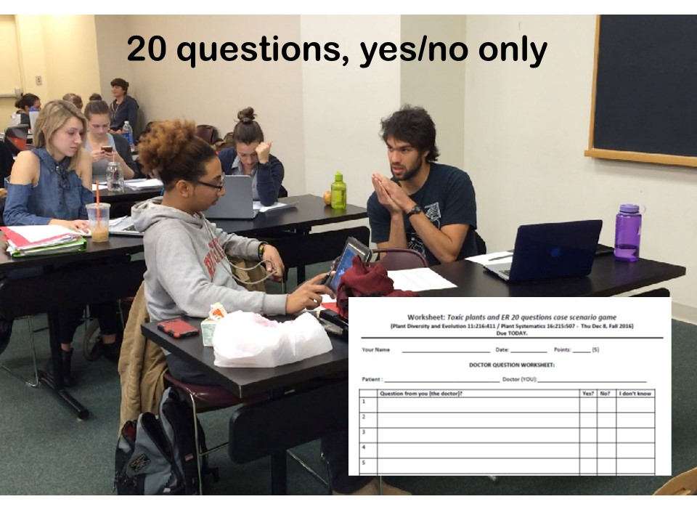
Undergraduate and graduate students at Rutgers playing the ER toxic plant role play in the class Plant Diversity and Evolution taught by Dr. Lena Struwe.
© Susanne Ruemmele, Rutgers University, used with permission

