Acquire a map of your neighborhood from Google Maps or Google Earth.
Indicate your residence and your 10 trees (street trees or park trees.)

Scientific Name: ________________________ Location:_______________________

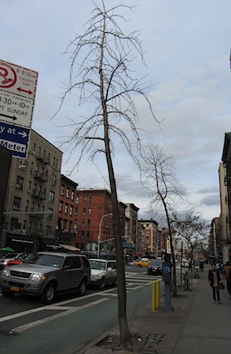 | 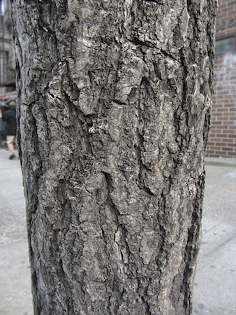 | 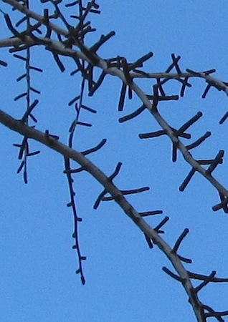
Sample number:  Family name:  Common name:  Native or Exotic:  Natural Distribution: | DBH:  Estimated Height:  Value (Annual):  Maximum Life Span:  Estimated Lifetime Value: | Bark/Trunk:  Smooth/Textured  Peeling/Not peeling  Breaks on bark:  Vertical/Horizontal/  Uneven  Lenticels:  Linear/Not linear
Leaf arrangement:  Alternate/Opposite  Leaf type:  Simple/Compound  Margin:  Entire/Lobed/Toothed | Inflorescence type:  Flower color:  Flower shape:  Pollination method:  Pollinator: | Fruit type:  Seed Type:  Seed Dispersal:
Picture of Leaf | Picture of Flower | Picture of Fruit or Seed

For each individual tree in your sample, record the phenology of flower, leaf, and fruit (be aware that trees in the same species will probably be slightly different):

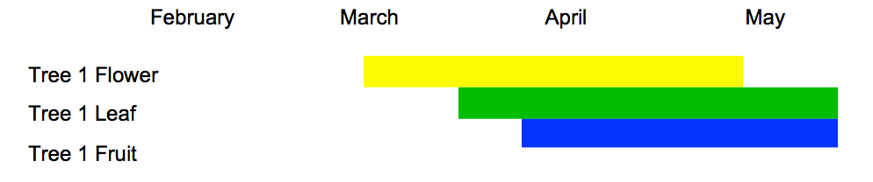

For each street tree in your sample, use the New York City Street Tree map to retrieve the annual value of its economic benefits: https://tree-map.nycgovparks.org/
What are cumulative annual benefits for your sample of 10 trees?

Look up the maximum life span of each tree species. Many variables affect the tree life spans, especially in urban settings, and ecosystem benefits change over time. Can you make a very rough estimate of the total economic value of your sample of 10 trees?

Which ecosystem service has the highest economic value?

